**Digital Speedometer(Featured at IEEE Explore)**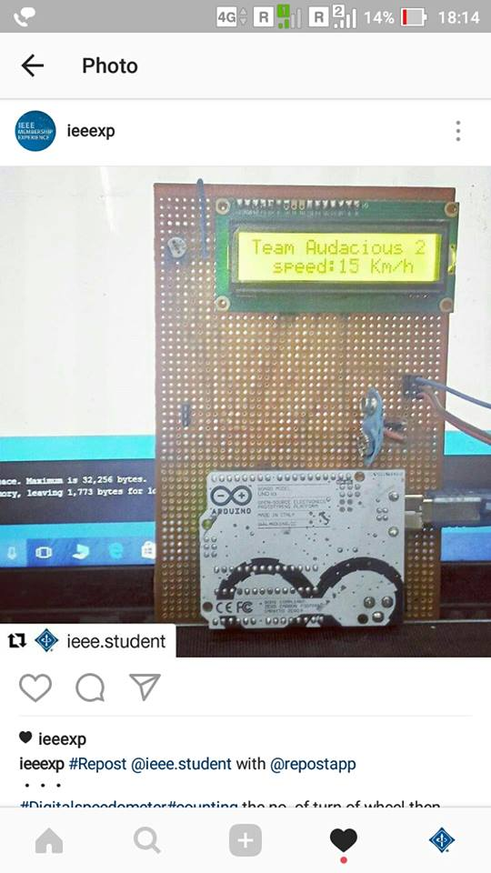

**By:** Dheeraj Yadav,3rd Year, ECE

**Introduction**: A speedometer or a speed meter is a gauge that measures and displays the instantaneous speed of a vehicle. Many modern speedometers are electronic. In designs derived from earlier eddy-current models, a rotation sensor mounted in the transmission delivers a series of electronic pulses whose frequency corresponds to the (average) rotational speed of the driveshaft, and therefore the vehicle's speed, assuming the wheels have full traction. The sensor is typically a set of one or more magnets mounted on the output shaft or (in transaxles) differential crown wheel, or a toothed metal disk positioned between a magnet and a magnetic field sensor. As the part in question turns, the magnets or teeth pass beneath the sensor, each time producing a pulse in the sensor as they affect the strength of the magnetic field it is measuring. A computer converts the pulses to a speed and displays this speed on an electronically controlled, analog-style needle or a digital display

**Requirements**:

* + - * Arduino Uno
      * Hall Sensor
      * Hall Sensor Magnet
      * Electronics LCD
      * 9-V Battery
      * PCB
      * Variable Resistance
      * 220K Resistance
      * Headers

**Illustrations:**

Proteus Diagram

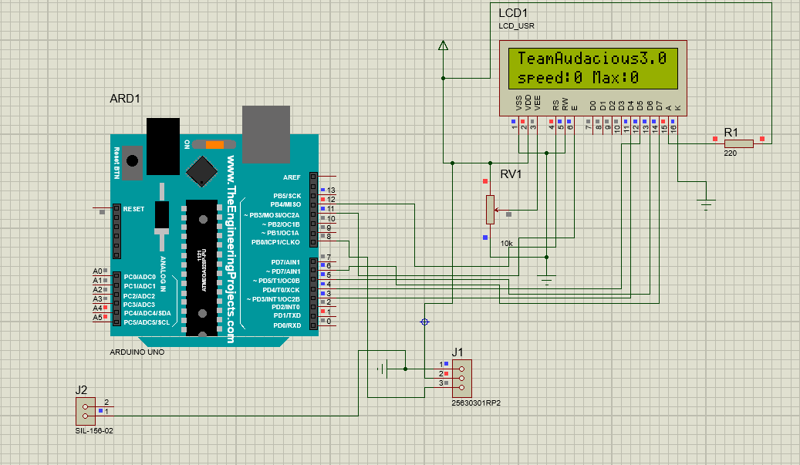

ARES Diagram

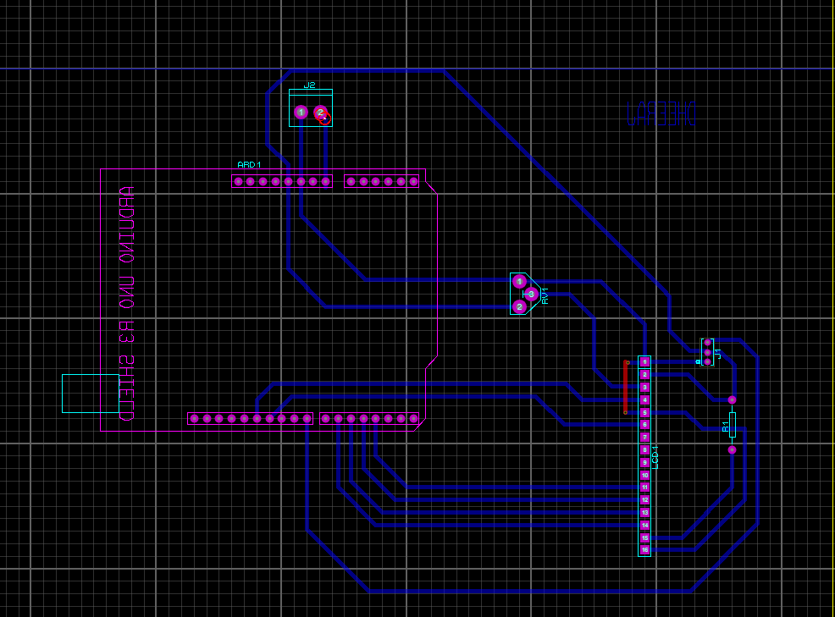

PCB Layout

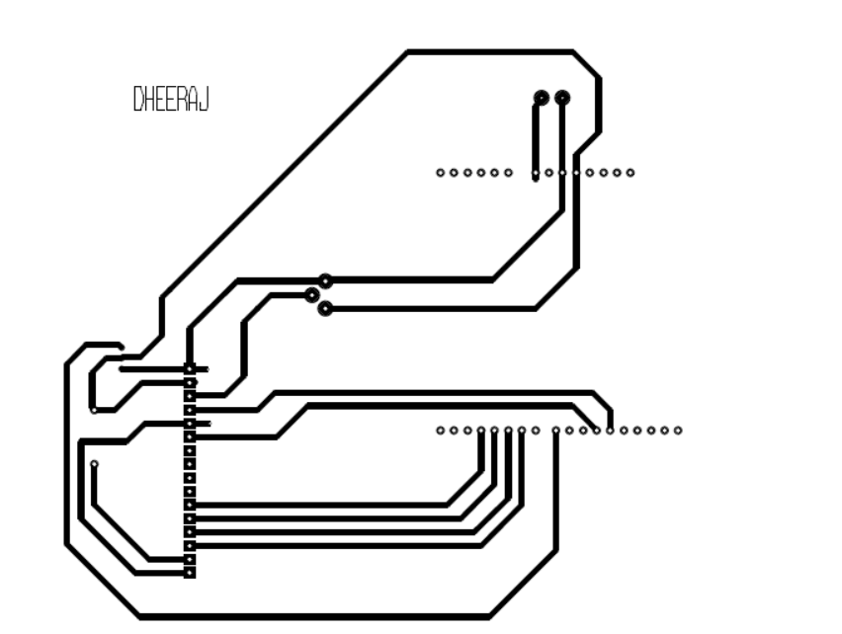

**Application:**

* The accurate data recording and indication meet the

stringent requirements of national and EU-wide regulations.

* Vehicles subject to tachograph regulations with separate

indication and recording.

* Indication of total distance travelled in the 7-digit LC display

with 100 meter digit.

* Speed pointer set to the legally required tolerance.
* Weight factor <<300gm

**Technical Information:**

* Measuring range 125 km/h
* Operating temperature - 25 ... + 70 °C
* Operating voltage 5v or 3.3v
* Inputs Hall sensor
* Outputs 2 x v-pulse, 4 Imp/M, driving/stop signal
* Accuracy Speed pointer set to the legally required tolerance
* Design on PCB
* weight approx 300gm

**Conclusion:** By the Digital Speedometer we can control over speed of vehicle and the main thing is by the use of this the consumption of fuel is decreases.